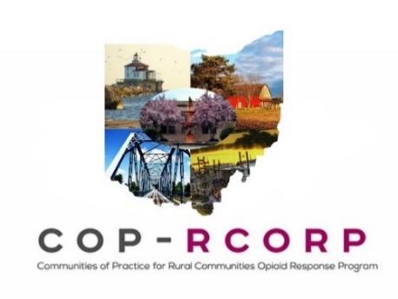
Consortium Meeting
February 25, 2020--1:00-2:30pm
ZOOM: https://zoom.us/j/406141526
Phone only: Dial (646) 876-9923; enter meeting ID: 406 141 526

1:00-1:05 Welcome, roll call and attendance Matt Courser
PIRE: Matt, April, Casey. OU: Carrie, Laura, Holly, Nicole Ashtabula: Miriam, Pat Wagner, Bridget Fairfield: Toni, Josh, Patti Waits Sandusky: Stacey Seneca: Washington: Hilles, Dr. Wittberg
1:05-1:45 Sharing our work on Naloxone Holly Raffle & COP-RCORP
Members
Ashtabula shared they had the most success when they met people where they were. They went to places where people were already gathering for other reasons (ie remote area med event, PART conference, drug court, etc). Sometimes giving away 30-40 kits and get a mini-training. Concerned that stigma, geography kept people from attending groups specific for naloxone distribution. Questions for Ashtabula – How do you do training when handing out kits? Health department has shortened paperwork and training. QRT has training downloaded on phones and tablets (video). Health Dept nurses can do training verbally within 15 minutes. Ends up being a shorter process.
Fairfield is targeting five zip codes, not the whole county. These are very small communities. Have done some community trainings with good success. Also work with local hospital through Project DAWN. They do trainings every quarter. These are 2 hours in length. QRT makes sure family or person with SUD has a Narcan kit. Planned to attend a basketball game at a high school that encompassed three zip codes, but the principal decided a week prior that this would not be a good fit. Now working on summer events, including a community care day. Fairfield developed a PSA on Narcan with 211 as point of contact agency. Everyone appearing in the PSAs are from the community. Questions for Fairfield: Was funding for the PSA from a grant? How much did it cost to get produced? Funded through Collective Impact grant. The total grant was 60K. Not sure what the amount was specifically for the PSAs. Grant also included brochures, lock boxes, deterra bags.
Sandusky County partnered with EMS director and public health nurse, Laura, to do trainings through the health department. Promoting Harm Reduction Ohio website. They are using the toolkit produced by OH Dept of Health. Offering throughout the county at different times of day. Considering radio PSAs, flyers, and word of mouth through recovery and treatment community to market training sessions. 3-4 years ago board of health was reluctant to distribute naloxone, but are now willing. Worked to be intentional about contract with EMS with a deliverable-based contract, tied to performance measures. Questions for Sandusky –
Seneca County has two projects addressing harm reduction. Neither are funded by the MHRS board, but the board stays connected with them to provide support and receive data. Harm Reduction Ohio provides free Narcan to people who use opioids or who have frequent contact with people who use opioids. HRO has four strategies. In Seneca, they do direct outreach at street level and a mail order option. Local distributor received 30 IM kits in October and 30 nasal kits in December. Not clear how much training is provided when the naloxone is distributed. The other project is through FACTOR, Seneca County health Department, and Orianna House. Education is provided with distribution through one-on-one training, videos and handouts. Expected to distribute 500 kits by the end of their grant period. Had about 20 people at their first training. They felt they need to increase advertising of the event. Also concerned about stigma making people reluctant to come to an event centered around Narcan. Washington County noted Harm Reduction Ohio is also operating in their county.
Washington County currently working to develop consortium and next steps in moving forward.
Discussion on value of sharing and presenting: Communities felt it was valuable to hear new ideas and experience other counties have had through the process. Also, helpful for communities to reflect on their own progress and history.
1:45-2:00 CLAS Standards Workgroup CLAS Workgroup
Laura introduced the workgroup. Robin summarized how the work began through reviewing the standards. Pat Wagner noted each community worked with local members to get a sense of where the local consortium stands (if they planned/did not plan to implement), did SWOT analysis locally and chose a few standards to implement based on the SWOT analysis.
Discussing value of the workgroup. Pattie (Fairfield) said it was helpful to break this down into tasks, share and get feedback to get a sense of the common issues for each county. It felt overwhelming at first, but the small workgroup made it much more manageable. Pat noted that the people currently implementing standards will be able to help those planning to implement. It was also helpful to share data locally.
Next steps for local consortia/how to use workgroup approach. Sandusky used a small group to go through the assessment tool, using consensus process. Really liked the checklist. Laura noted each community is using a different process to complete the checklist based on what process works best in their local community.
At the March 9th meeting, Dr. Dawn Thomas will talk about OHMHAS perspective on CLAS standards.
2:00-2:10 RCORP-I performance measures: update and materials Nicole Yandell & COP-RCORP
Members
Materials and webinar are posted in the members only section of the website. There is a word document that communities will complete and return to Nicole. Some of the performance measures may be more suited for hospitals/treatment centers and may not apply. Communities should reach out to Nicole or their TA provider with questions. Nicole presented the timeline. Community submission is due to Nicole on Feb 28th. Final submission due to HRSA on March 31st.

2:10-2:15 RCORP-I Quarterly Report #2 Carrie Burggraf

Q2 Progress Report is due at the end of March. HRSA will not be using the same format as the Q1 report. They want to standardized reports across all RCORP-I projects. Some of the new items will require consensus. OU/PIRE will send out guidance on this process soon. We will need OUD/SUD funding updates (send to Matt or Holly). We will need prioritization form updates (Jan-March). We will pull information from that form for the Q2 report. Updates are due March 20th.
Questions: They are asking about direct services provided by backbone organization. Questions reference individuals screened for SUD, etc. If you are not providing those services, just note that and skip that section. Holly noted the information is not collected as a benchmark or grade, so it’s okay to skip sections or mark them as zeros.

2:15-2:20 Scheduling a F2F Consortium Meeting in May: Matt Courser
Communicating our Public Value
Casey will send out Doodle poll later this week/early next week to find a date in May for this F2F meeting. This will likely occur in Dublin, OH. The focus of the meeting will be on Public Value.

2:20-2:30 Wrap-up, support needs, next steps Matt Courser & COP-RCORP
ODH Non-fatal overdose data Members
Matt shared the ODH Non-fatal overdose data dashboard. These are based on ER visits, reported by counties. Includes data tables, trends, and maps. The link to this dashboard is on the COP-RCORP website.
Materials for local SWOT assessment will go out after this meeting.
Handouts:
- Agenda
- Slide deck
Concrete Action Steps:
- Review your organization’s other OUD/SUD funding (federal, state, local) and notify Matt and Holly of changes
- Prepare for quarterly reporting
Suggested Deadline Reminders:
- March 18, 2020: Performance measure submission form due to Nicole Yandell (yandell@ohio.edu)
- March 21, 2020: Your contributions to Q2 Progress Report (prioritization forms and updates to OUD/SUD funding) due to your TA provider
- TBD: Any other Q2 Progress Report Updates (pending HRSA revision)
Next Meeting: March 24, 2020, from 1:00pm until 2:30pm
See Page 2!

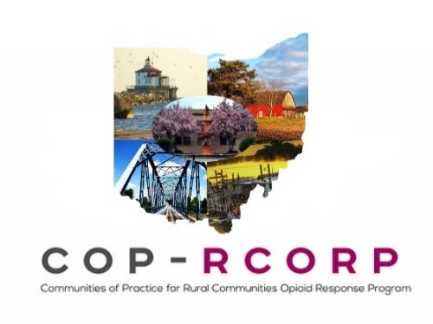

COP-RCORP Core Planning and Implementation Value(s)
- Consider how the work of the COP-RCORP Master Consortium impacts the affordability and accessibility of OUD/SUD services in the COP-RCORP Service Area.
Current (February 2020) RCORP-Implementation Core Activities of Focus:
- Prevention #1 – Naloxone
- Prevention #2a – CLAS Standards
- Treatment #3 – Workforce Development (NHSC)
RCORP-P Strategic Plans (Community-level):
Each COP-RCORP Local Consortium uses strategic plans created with RCORP-P funding to guide and complement its work to implement the RCORP-I core activities.
- Prevention – Supply Reduction
- Prevention – Demand Reduction
- Prevention – Harm Reduction
- Treatment
- Recovery Supports
- Workforce Development
- Sustainability
Completed COP-RCORP Consortium Work on RCORP-Implementation Core Activities:
[As we complete work on RCORP-I Core Activities, we will build out this section]

